­

One World No Waste

MEDIABazaar

ORDER PROCESSING SIMPLIFIED

At MediaBazaar we strive to provide transparency and continuous improvement of the order process in order to orchestrate a superior

experience for our customers, empowerment for our team and aspirational pride for our stakeholders.

productivity

reporting

organization

insights

We foster value

to our customers by offering

invigorated productivity and services that

enlarge the marketplace based on deployment of original, effective, trusted, and efficient niche technology.

We are a technology driven organization that facilitates a clearer understanding of revenue and organizational challenges from a diverse group of sales channels.

Data filtering options on our dashboard will get you that extra information needed to gain a leg up on your competition. View metrics anywhere from shipping speed to income per capita.

Looking to increase those margins? Discover the benefits!

• Sales location: State, Region, World

• Periodic Sales Reports (PDF Compatible)

• Average Shipping Prices, Updated Weekly

• Real Time Price Adjustments to remain Competitve

• Universal Notes Functionality

379 Nunnally Farm Rd

Monroe GA, 30655

407-555-1212 ph

555.543.5433 fax

www.mediabazaar.com

Personalized order processing solutions that work for you.

all in one easy to use dashboard!

Owner’s manual including step by step support of the operational

process located on our web page. This is provided

to assist with confusions

and FAQ.

DATA MAPPING

Using our website’s geological data mapping features you may find critical context for your metrics. It’s important to understand the distribution or presence of your organization across a city, state, country, or the world. Using our maps and its real time data, compare activity across several locations at a glance.

APPLICATION MANAGEMENT

The wide range of advantages provided by our APIs for clients and developers results more efficient and personalized data reporting from top applications. You can expect a personalized layout with the ability to customize the content you use the most. In the age of data sharing, more scope is available offering users the ability to distribute your content to newer or larger audiences.

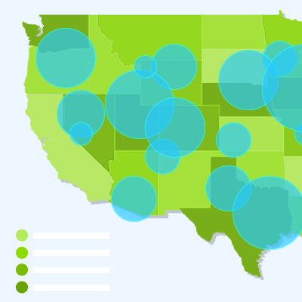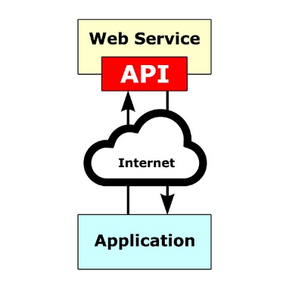4

DAILY REPORTING

Viewing the daily reports in our dashboard, you are able to analyze more data in a more efficient manor. Our graphics and charts make it easy to see where you are thriving and where you can look to improve.

SHIPPING DATA

Save time and increase organization by viewing any and all of your shipping data from completed orders in one easy to use dashboard. All data is updated automatically from the release of holds to the completion of sales.

PRICE UPDATES

Enjoy countless pricing updates to your active listings! This is achieved through our API where your items are compared to market equivilents in order to maintain the most competitive price point possible.

At MediaBazaar we are targeted towards small and mid level merchants witth limited staff who perform multiple organizational roles and typically purchase in small volumes, but offer a variety of inventory, Our working APIs pull data from sites such as SellerActive and ShipStation automatically to provide you with updated data.

flexible reporting for

your business needs

WE’VE WORKED WITH A GROUP OF DIVERSE SALES CHANNELS. HOW CAN WE HELP YOU?

Visit us at our website at insertwebpageurlhere.com for access to our dashboard or more information about our product.

inputs from the top marketplaces!

•

•

•

•

• Genitus, te vero, erat.